LED Interfacing to Arduino:

Introduction:
LEDs (Light Emitting Diodes) are the most commonly used of electronic components. They are everywhere – torches, displays, indicators, etc. Every project will eventually end up having atleast one led.

Requirment:
- LED
- Current Limiting Resistor
- Arduino Board

Hardware configuration:

The LED has a two node long and short.The Long of the LED is the Anode (Positive Terminal!) and the short led is the Cathode(Negative Terminal).
The LED interfacing steps are given below.

Step1: place the LED in breadboard.

Step2:Place a Current Limiting Resistor between the negative terminal of the LED and the '-'ve terminal on the power rail of breadboard.

Step3:Take a wire from the pin marked 'GND' of your arduino and connect it to the '-'ve power rail of the breadboard. (Now all points of the '-' ve power rail will be connected to the ground of the arduino!)

Step4:Next, Connect a wire between the 11th pin of the arduino and the positive terminal of the LED. This is going to be our control line for the LED.

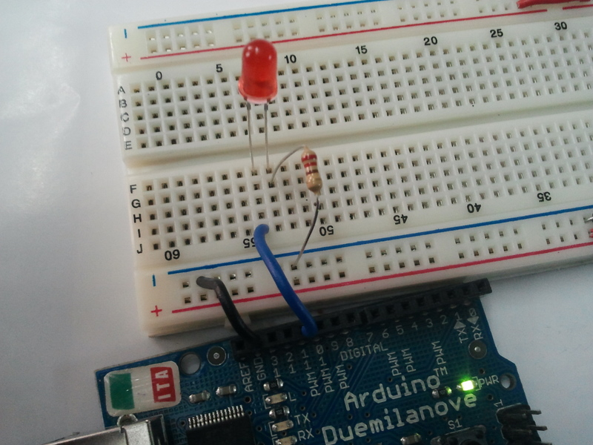

Programing:(source code)

Programming to control the LED:

The following code can controll the LED:
/*
link
Turns on an LED on for one second, then off for one second,repeatedly.This example code is in the public domain.
*/
void setup() {
// initialize the digital pin as an output.
// We have our LED connected to Pin 11
pinMode(11, OUTPUT); // Sets the 11th pin as an Output pin
}
void loop() {
digitalWrite(11, HIGH); // set the LED on
delay(1000); // wait for a second
digitalWrite(11, LOW); // set the LED off
delay(1000); // wait for a second
}

Installation:
The source code copy to the skeches of arduino and compile (there is verify option) as shown given below.
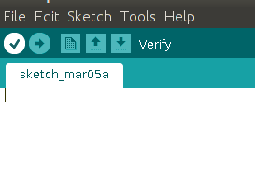

And then uploding the source code.(there is uploding option) to the Arduino board.(software) as shown given below.
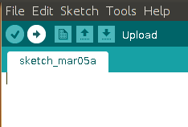

Troubleshooting:
FAQ:
Maintainers:
Duryodhan Aldar (durva.ges@gmail.com)

References: http://quickstartkitforarduino.blogspot.in/

